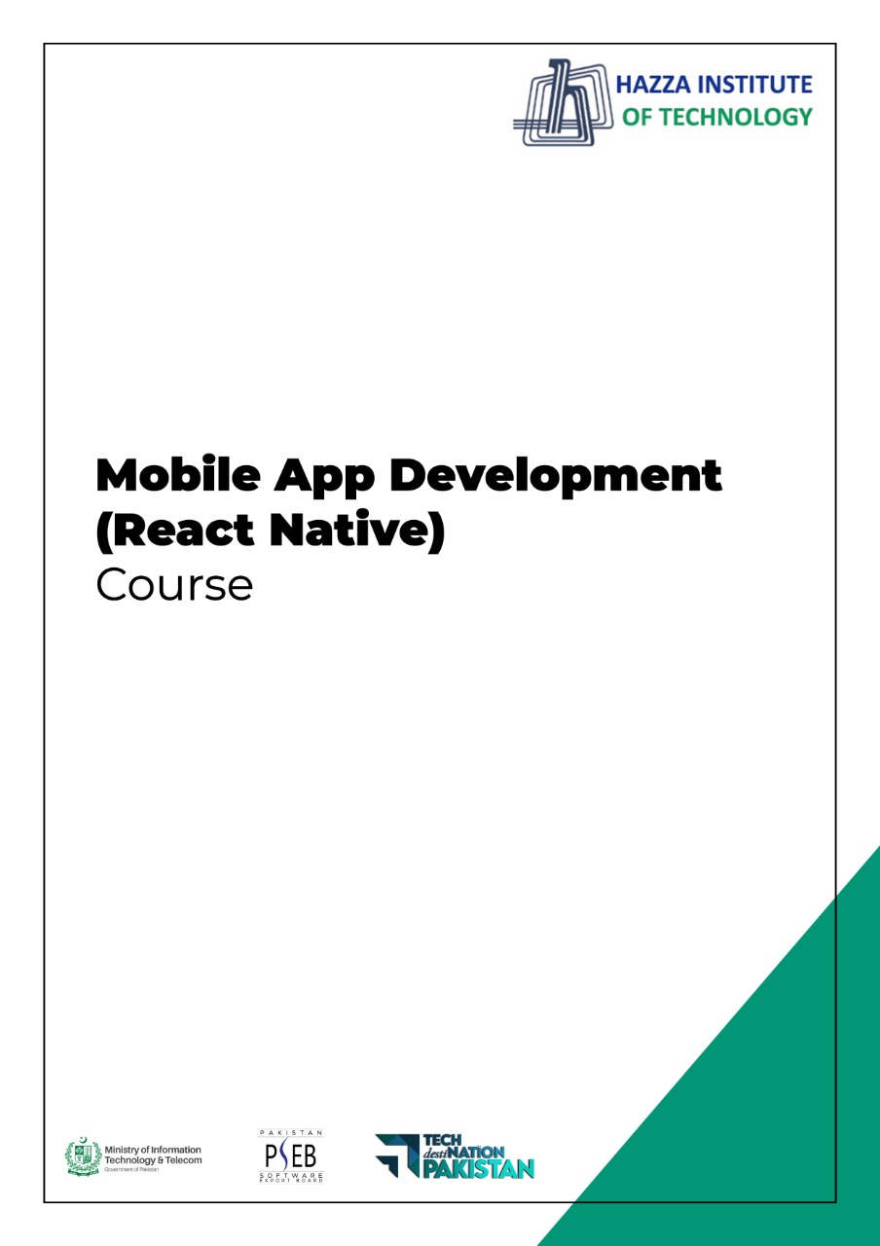

**(Flutter)**

Flutter Lab 3 (Session 1)

**Total Time:**

**3 hours (session-1)**

**Pre-Lab Activities:**

* + Basics of Flutter
  + Familiar with Android Studio and Flutter Application Mode
  + Familiar with Layout Widgets

**Learning Outcomes:**

* Demonstrate the knowledge of Flutter to design stateful, cross-platform, and interactive user interfaces for mobile applications.

**Student Activities:**

* Student create a new flutter project in Android Studio and Write the code for above application.

**Lab Tasks 1:**

* + Modify the default application, which you access, when you first time create a new project. You have only change the background color.

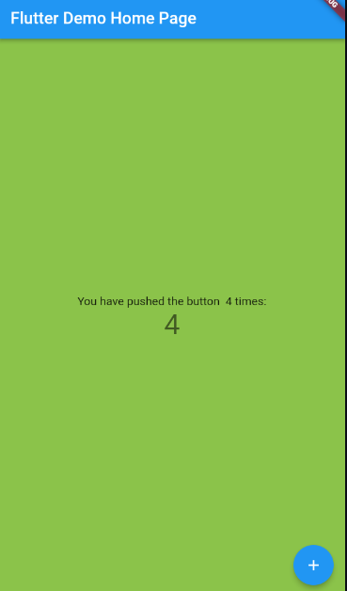

**Lab Tasks 2:**

* + Modify the code used to develop above task. Remove stateless and statefull classes and use the main function to develop the same app again with displaying a simple Text “Hellow Word”.

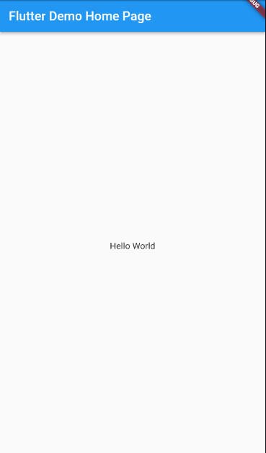

**Lab Solutions:**

**LAB 3.1 : Practicing Basic Flutter application design.,**

**CODE:**

|  |
| --- |
| **import 'package:flutter/material.dart';**  **void main() {**  **runApp(MyApp());**  **}**  **class MyApp extends StatelessWidget {**  **// This widget is the root of your application.**  **@override**  **Widget build(BuildContext context) {**  **return MaterialApp(**  **title: 'Flutter Demo',**  **theme: ThemeData(**  **primarySwatch: Colors.blue,**  **),**  **home: MyHomePage(title: 'Flutter Demo Home Page'),**  **);**  **}**  **}**  **class MyHomePage extends StatefulWidget {**  **MyHomePage({Key? key, required this.title}) : super(key: key);**  **final String title;**  **@override**  **_MyHomePageState createState() => _MyHomePageState();**  **}**  **class _MyHomePageState extends State<MyHomePage> {**  **int _counter = 0;**  **void _incrementCounter() {**  **setState(() {**  **_counter++;**  **});**  **}**  **@override**  **Widget build(BuildContext context) {**  **return Scaffold(**  **backgroundColor: Colors.lightGreen,**  **appBar: AppBar(**  **title: Text(widget.title),**  **),**  **body: Center(**  **child: Column(**  **mainAxisAlignment: MainAxisAlignment.center,**  **children: <Widget>[**  **Text(**  **'You have pushed the button $_counter times:',**  **),**  **Text(**  **'$_counter',**  **style: Theme.of(context).textTheme.headline4,**  **),**  **],**  **),**  **),**  **floatingActionButton: FloatingActionButton(**  **onPressed: _incrementCounter,**  **tooltip: 'Increment',**  **child: Icon(Icons.add),**  **), // This trailing comma makes auto-formatting nicer for build methods.**  **);**  **}**  **}** |

**LAB 3.2 : Practicing Basic Flutter application design.,**

**CODE:**

|  |
| --- |
| **import 'package:flutter/material.dart';**  **void main() => runApp(MaterialApp(**  **title: 'Flutter Demo',**  **theme: ThemeData(**  **primarySwatch: Colors.blue,**  **),**  **home: Scaffold(**  **appBar: AppBar(**  **title: Text('Flutter Demo Home Page'),**  **),**  **body: Center(**  **child: Text("Hello World"),**  **),**  **),**  **));** |